**CHAPTER-1**

**INTRODUCTION**

**1.1 Introduction**

* This is online book selling and buying website. By this website user can able to get information (Personal detail and contact number) of old books and the new books.
* By using this website user can upload details of his/her book and personal contact to sell books. This website provides c2c (customer to customer) relationship.

**1.2 Purpose of the System**

* The purpose of this website is to save time, save money.
* This website provides second hand books seller information so the user gets books in lower price.
* This website also provides new book seller information.
* Automatic acknowledge about new arrivals.
* To provide user friendly navigations.
* Reuse of books it is helpful for the environment.

**1.3 Scope of the System**

* This system is in web-based, in which can only be accessed from the Internet.
* This system is only providing seller information to the user so it saves time.
* C2C relationship provides using this site.
* It provides a user friendly environment.
* It provides a facility of user feedback.

**CHAPTER-2**

**PROJECT PLANNING**

**2.1Software Process Model**

1. In prototyping model initially the requirement gathering is done.Develop and customer defines overall objectives; identify areas needing more requirement gathering.

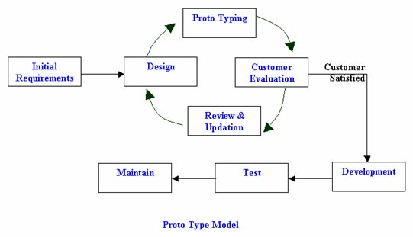

**FIG1.Proto Type Model**

1. Then a quick design is prepared. This design represents what will be visible to user in input and output format.
2. From the quick design a prototype is prepared. Customer or user evaluates the prototype in order to refine the requirements. Thus prototype is tuned for satisfying customer requirements. Thus prototype is important to identify the software requirements.
3. When working prototype is built, developer use existing program fragments or program generators to throw away the prototype and rebuild the system to high quality.

5. Certain classes of mathematical algorithms, subset of command driven systems and other application where results can be easily examined without real time interaction can be developed using prototyping paradigm.

**2.1.1 Advantage of Prototyping**

1. Software applications that are relatively easy to prototype almost always involve human-machine Interaction (HCL) the prototyping model is suggested.
2. A general objective of software is defined but not detailed input, processing or output requirements. Then in such a case prototyping model is useful.
3. When the developer is unsure of the efficiency of an algorithm other adaptability of a system then prototype serves as a better choice.

**2.2 Project planning**

A **project plan** is “A formal, approved document used to guide both project execution and project control. The primary uses of the project plan are to document planning assumptions and decision, facilitate communication among stakeholders, and document

approved scope, cost, and schedule baselines. A project plan may be summary or detailed.”

“A statement of how and when a project’s objectives are to be achieved, by showing the major products, milestone, activities and resource required on the project.

|  |  |  |  |
| --- | --- | --- | --- |
|  | | | |
|  |  |  |  | |

### “Project Planning Activity chart:

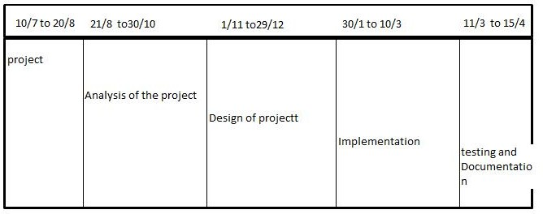

**(Activity Chart of Project Planning)**

* + 1. **Project Development Approach and Justification**
* It begins with requirements gathering.

* Developer and Customers meet and define the overall objectives of the software, identify whatever requirements are known and identify the areas which require further definition.
* In many instances the client only has a general view of what is expected from the software product. In such a scenario where there is an absence of detailed information regarding the input to the system, the processing needs and the output requirements, the prototyping model may be employed.
* This model reflects an attempt to increase the flexibility of the development process by allowing the client to interact and experiment with a working representation of the product.

**CHAPTER-3**

**SYSTEM ANALYSIS**

**3.1** **USERS**

1. Admin
2. Buyer
3. Seller

**3.1.1 Admin**

* Admin is whole system are handle.
* Only admin can change features of the website.
* He will keep all the right reserved for his services.
* Then insert, delete, update are process do to admin.
* Functionality of admin modules are as below :-

Add Books

Show Register user

Manage User account

**3.1.2 Buyer**

* Buyer is used to buy the Books as per his/her choice
* Then insert, delete, the books as per selling account.
* Functionally of buyer modules are as below :-

  View Books details

Buy Book as per own needs

Send Message to seller to buy or exchange the book

**3.1.2 Seller**

* Seller is used to sell the Books using this Website.
* Seller can give the image of the Book.
* Seller can insert, delete, the Book and its details about the Book
* Seller can send replay back message to Buyer
* Functionally of buyer modules are as below :-

  Add Properties

Insert the Books details

Delete Books details

**3.2** **FEASIBILITY STUDY**

Feasibility study of the system is very important stage during system design. Feasibility studies aim to objectively and rationally uncover the strengths and weaknesses of the existing business or proposed venture , opportunities and threats as presented by the environment , the resources required to carry through and ultimately the prospects for success.in its simplest term , the two criteria to judge feasibility are cost required and value to be attained. As such, a well-designed feasibility study should provide a historical background of the business or project, description of the product or service, accounting statement, details of requirements and tax obligations. Generally, feasibility studies precede technical development and project implementation

**Mainly following aspect is taken into this stage:-**

1. **Technical feasibility**
2. **Economic feasibility**
3. **Operational feasibility**

**3.2.1 Technical Feasibility**

The technical requirement for the system is economic and it does not use any other additional Hardware and software.

1. We have preferred Microsoft visual studio 2008 as front end and Microsoft SQL server 2008 as back end as both these software are easily

Available and the company have its licensed version.

1. The employees in the company have been trained to use this software. Reckoning with the aforesaid point, it is technically feasible.

**3.2.2 Economic feasibility**

* The system being developed is economic with respect to School or Collage’s point of view. It is cost effective in the sense that has eliminated the paper work completely.
* The system is also time effective because the calculations are automated which are made at the end of the month or as per the user requirement.
* The result obtained contains minimum errors and are highly accurate as the data is required.

**3.2.3 Schedule feasibility**

**1.** Project are initiated with specific deadline .we need to evaluate whether the deadlines are mandatory desirable. Time is the one of the critical factor in the development of any system but this kind of feasibility is hardly perfect in any system.

1. We have been asked to complete the project within the working days of the organization having of 4 months approximately. So we have managed to complete the project before given deadline.

**3.2.4 Operational feasibility**

1. Operational feasibility measure how well the solution will work in the organization and how will end –user feels about the system.

2. It will provide advantageous and reliable services*.*

3. The proposed system makes a best effort to satisfy user requirements.

**3.3 REQUIREMENT SPECIFICATION**

**3.3.1 Functional Requirement**

1. Membership Registration
2. Books Details
3. Member Details

**3.3.2 Non-functional Requirement**

1. Message Facility
2. Notification
3. Contact Details

**3.4 Hardware and Software Requirement**

**3.4.1 Software Requirement**

* Web-Browser(Mozilla Firefox, Google Chrome, Internet Explorer)
* Front End Tool: HTML 5, CSS 3, Java Script(JS) , JQUERY, Bootstrap3
* Back End Tool: ASP.NET(Using C#)
* Windows Operating System: Window 7,8.1,10
* Data Base Server: MSSQL SERVER-2012
* Development End: AMD A4-5000 APU with Radeon(TM) HD Graphics

Asp.net (MSsql server)

**3.4.2 Hardware Requirement**

* Pentium- IV Intel 80486
* RAM: 512MB or above
* HDD : 20 GB or above
* Monitor
* Keyboard
* Mouse

**3.4.3 Documentation**

* + Microsoft Word 2010 for documentation
  + Power point 2010 for presentation
  + EDRAW MAX – 2007 for diagram

**3.5 Construction**

**3.5.1 Hardware Limitation**

* The website requires the 512MB RAM or above and the HDD can have 20 GB or above and the processor IV Intel 80486 is required in Hardware Requirements.

**3.5.2 Higher Order Language Requirement**

* We need to have a good Graphical User Interface (GUI) with user friendly environment which VS provides

**3.5.3 Reliability Requirement**

* The main reliability requirement is a validation used.
* Without proper validation the system would not allow to enter the value into the database.
* For e.g. in the name field only characters are allow and user not allow any dummy values, the validation check all these things. Any none value is not allowed in the compulsory fields.

**3.5.4 Safety and Security Condition**

* The username and password authentication has been provided for the login.

Assumptions and Dependencies:

* The project was started with the assumption that we would be given the necessary

support the form of h/w and s/w resources. My project depends a lot on the inputs.

* User has the basic knowledge of the windows environments.
* The project design is mainly created by keeping in mind the dependency with languages.

**Chapter-4**

**SYSTEM DESIGN**

**4.1 DESIGN METHODOLOGY**

A software design is a meaningful engineering representation of a software product that is to be built. A design can be traced to the customer’s requirement and can be assessed for quality against predefined criteria.

In order to evaluate the quality of a design (representation) the criteria for a good design should:

* + Exhibit good architectural structure.
  + Be modular.
  + Contain distinct representation of data, architecture, interfaces and components (modules).
  + Lead to components that exhibit independent functional characteristics.
  + Lead to an interface that reduces that complexity of connection between modules and whit the external environment.
  + Is derived using a reputable method that is drive by information obtained during software requirement analysis?
  + To design this software we have used Object Oriented Design Method.

**What was the reason to choose this method is as under:**

* + It provides the feature like reuse, quality, an emphasis on modeling the real world, resistance to change, encapsulation and abstraction etc.
  + **Faster development:** this was the requirement of the project.
  + **Reuse of previous work:** This was required in the project because it is going toextend further to meet the other requirement of the organization.
  + **Increased quality:** this was the non-functional requirement of the organization.
  + **Modular Architecture:** this was required to meet the modification in the product.
  + **Better Mapping to the problem Domain.**
  + Only OOD provides the mechanism that enables the designer to achieve above with less complexity.

**4.2 DATA MODELING**

1. **Data Flow Diagram**

**LEVEL-0**

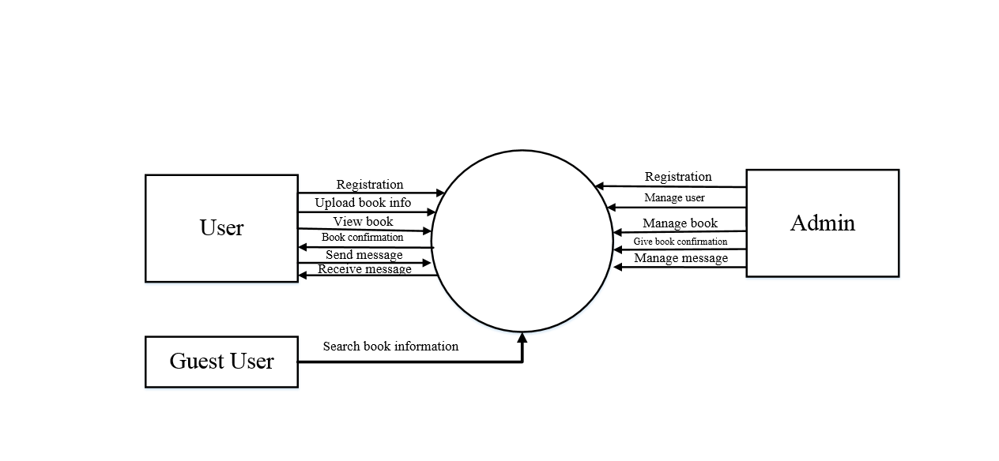

**4.2.1 DFD Level 0 Diagram**

**LEVEL 1:**

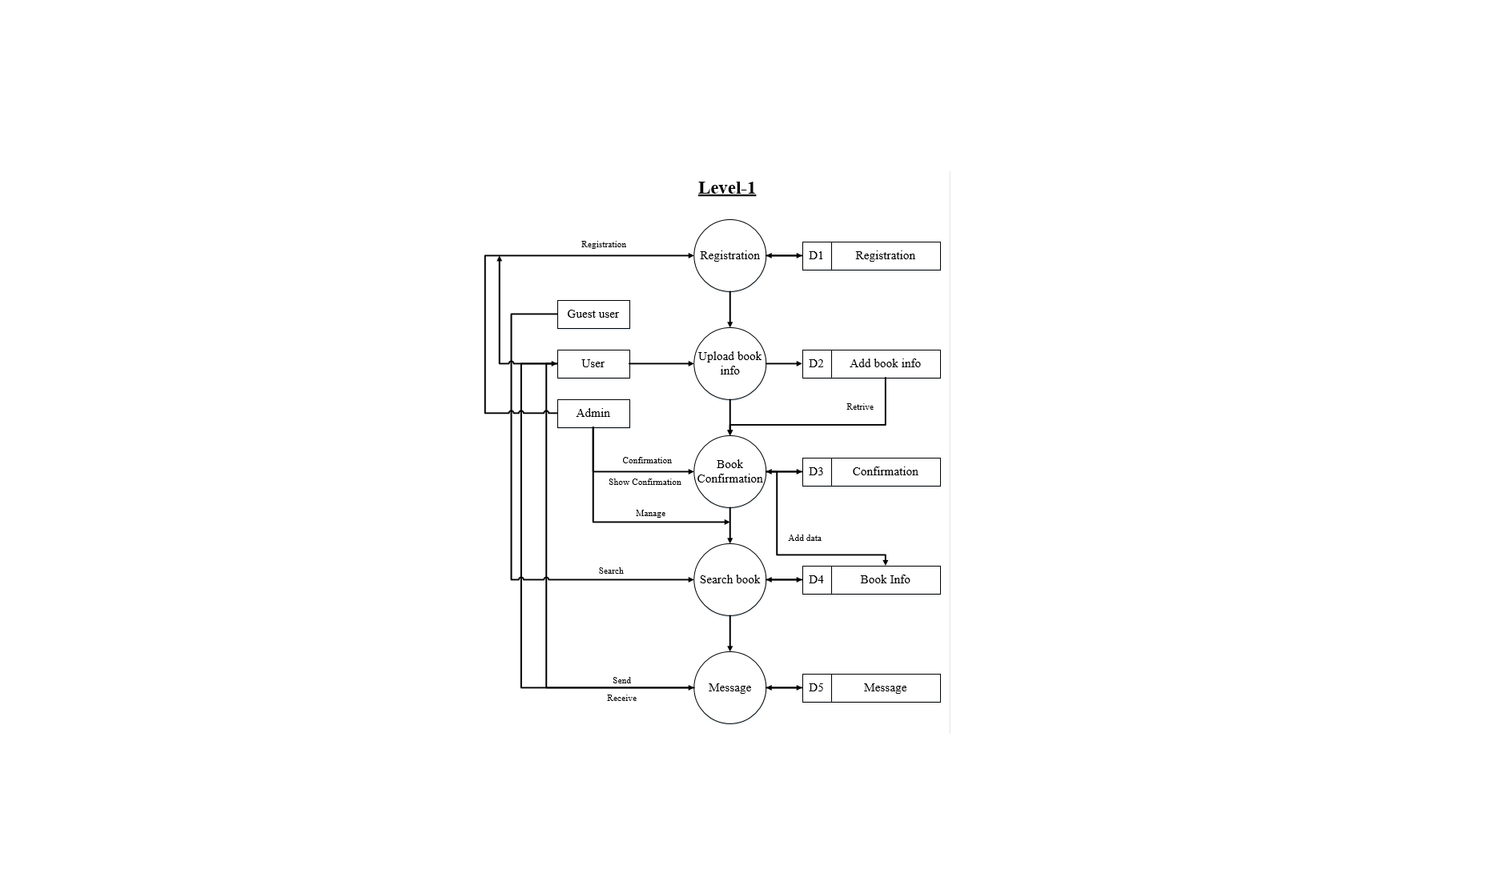

**4.2.2 DFD Level 1 Diagram**

**2. ER-Diagram:**

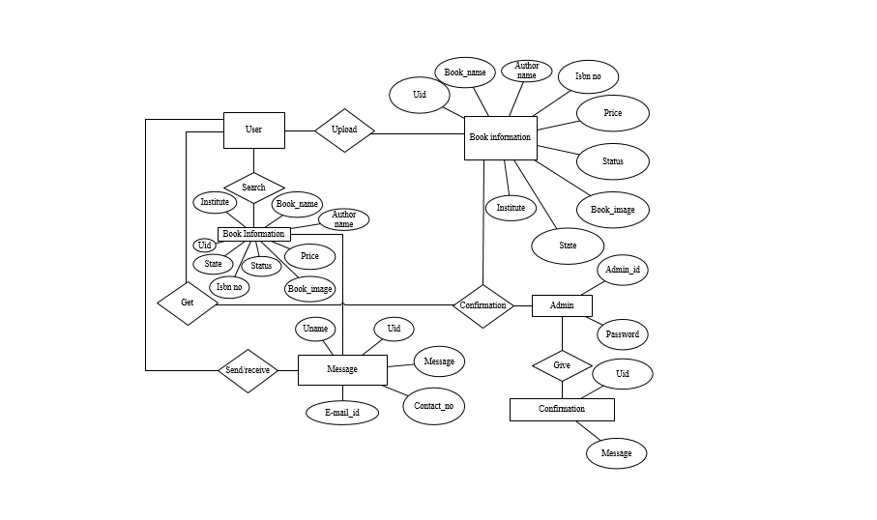

**4.2.3 ER Diagram**

**3. Use Case Diagram:**

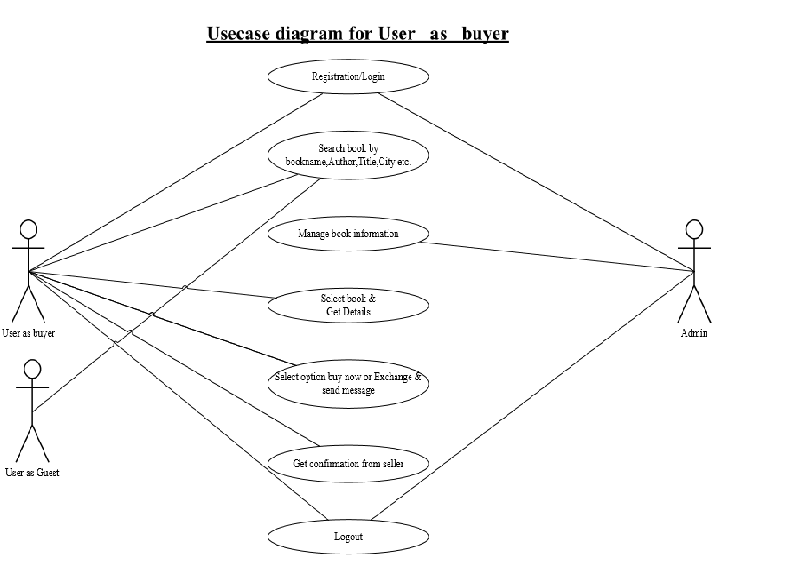

**4.2.4 Buyer Usecase Diagram**

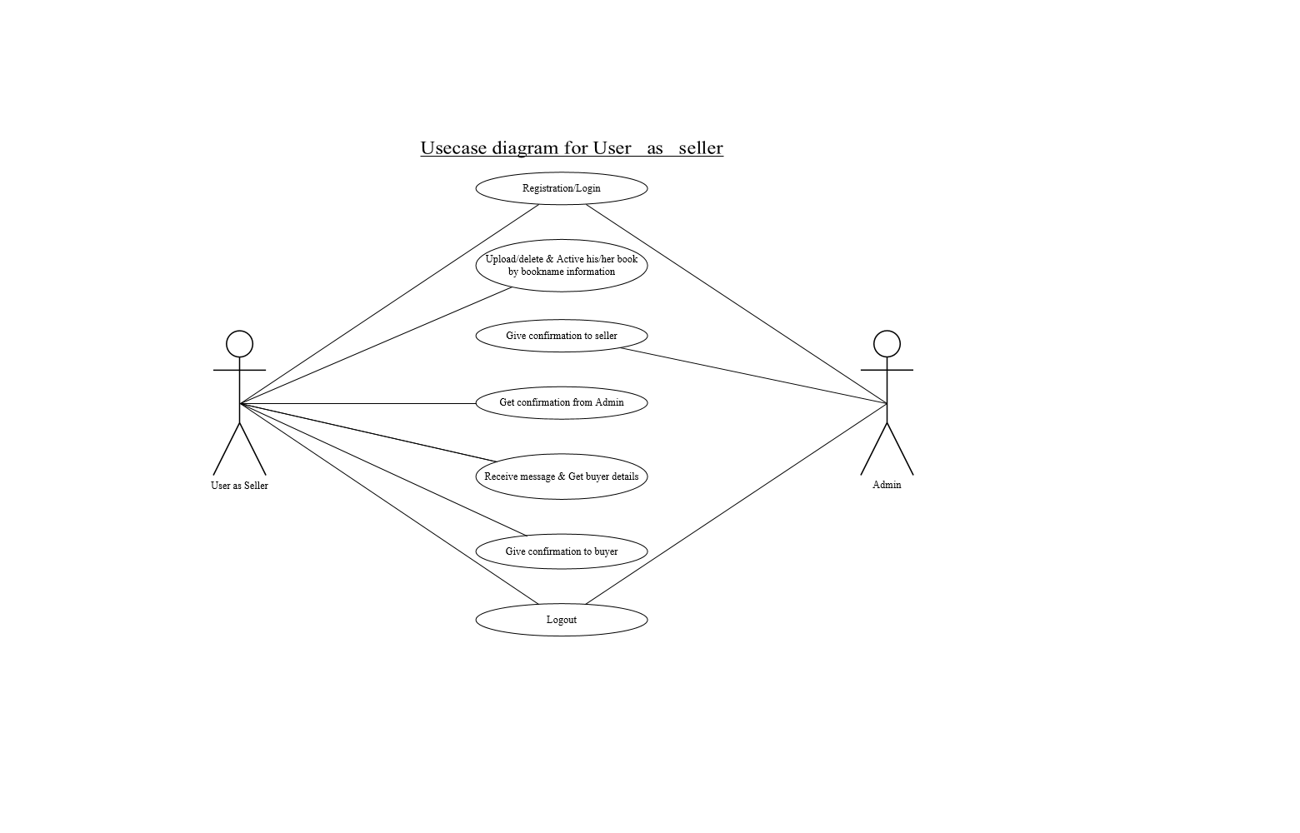

**4.2.5 Seller Usecase Diagram**

|  |
| --- |
| * 1. **Data Dictionary** |

1. **User master Table**

|  |  |  |
| --- | --- | --- |
| **FIELD NAME** | **DATATYPE** | **ALLOW NULL** |
| U_Name | Varchar(50) | NO |
| U_ID(Primary Key) | Int (10) | NO |
| U_Contactno | Int (10) | NO |
| U_Address | Varchar(50) | NO |
| Email_ID | Varchar(20) | NO |
| U_Password | Varchar(20) | NO |

|  |  |
| --- | --- |
| **FIELD NAME** | **DESCRIPTION** |
| U_Name | This field is used to store name of user |
| U_ID | This field is used to store id of user |
| Email ID | This field is used to store email id |
| U_Contactno | This field is used to store mobile number of user |
| U_Address | This field is used to store user Address |
| Password | This field is used to store password of user |

1. **Admin Master**

+

|  |  |  |
| --- | --- | --- |
| **FIELD NAME** | **DATA TYPE** | **ALLOW NULL** |
| Name | varchar(50) | NO |
| Email ID(Primary key) | varchar(50) | NO |
| Password | varchar(50) | NO |

|  |  |
| --- | --- |
| **FIELD NAME** | **DESCRIPTION** |
| Name | This field is used to store name of the user |
| Email ID | This field is used to store email ID of the user |
| Password | This field is used to store password of the user |

1. **BookMaster**

|  |  |  |
| --- | --- | --- |
| **FIELD NAME** | **DATA TYPE** | **ALLOW NULL** |
| B_Id(Primary key) | Int (20) | NO |
| B_Image | Image | NO |
| B_Name | Varchar(50) | NO |
| B_Author | Varchar(50) | NO |
| B_Price | Varchar(50) | NO |

|  |  |
| --- | --- |
| **FIELD NAME** | **DESCRIPTION** |
| B_ID | This field is used to store ID of the Book |
| B_Image | This field is used to store image of the Book |
| B_Name | This field is used to store Name of the Book |
| B_Author | This field is used to store author name of book |
| B_Price | This field is used to store Price of book |

1. **Message**

|  |  |  |
| --- | --- | --- |
| **FIELD NAME** | **DATATYPE** | **ALLOW NULL** |
| Msg_ID(primary key) | Int(11) | NO |
| Msg | Varchar(50) | NO |
| User_ID(Foreign key) | Int(11) | NO |

|  |  |
| --- | --- |
| **FIELD NAME** | **DESCRIPTION** |
| Msg_ID | This field is used to store ID of the Message |
| Msg_Name | This field is used to store Message Name of the User. |
| User_ID | This field is used to store ID of the User |

**Chapter-5**

**SCREEN SHOTS**

**5.1 Default page:**

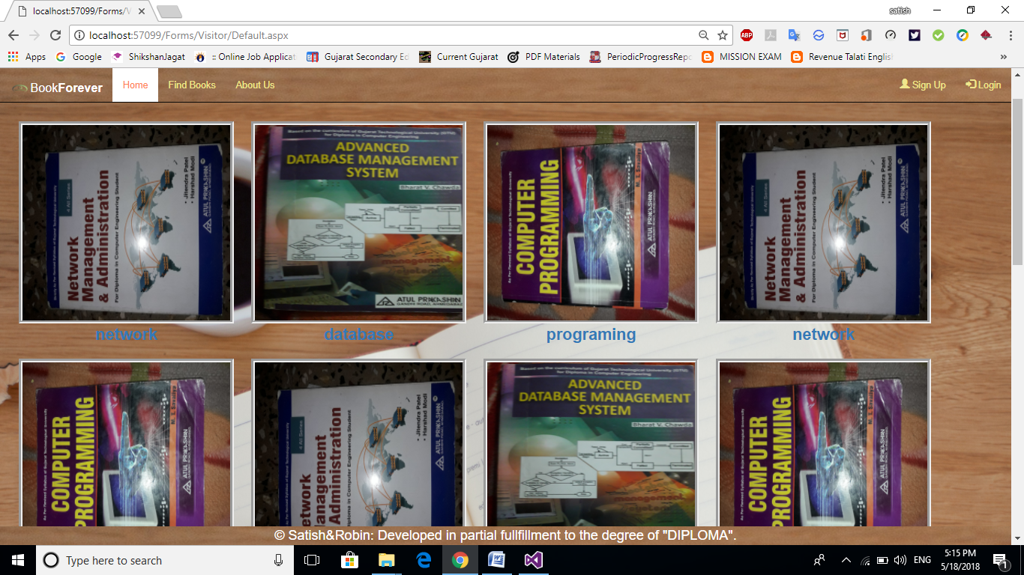

* This Page is Default Page for website User.
* This Page Show list of books which is available for Buy.

**5.2 Login page:**

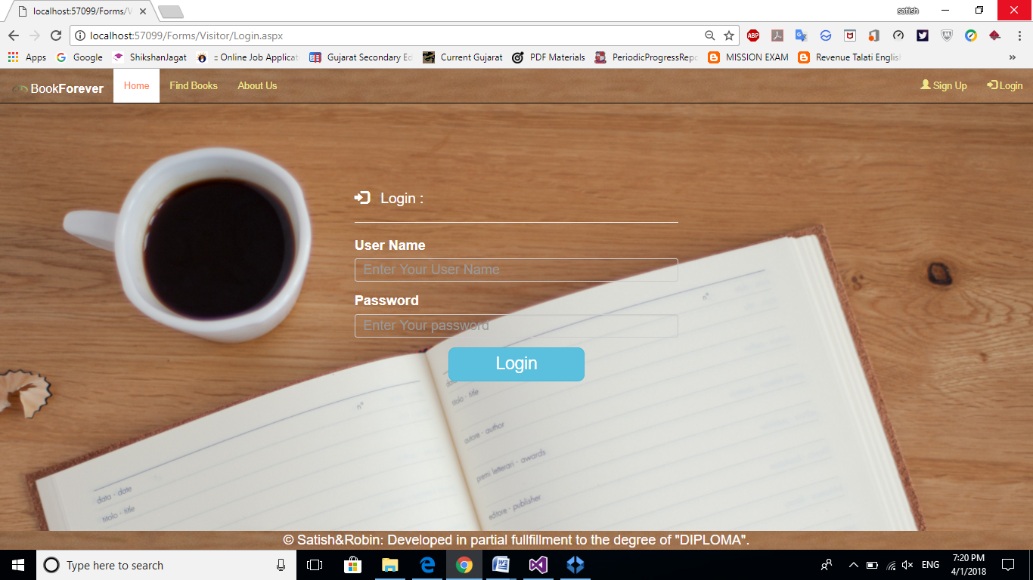

* This Page is Login Page for website User.
* This Page Contain Buyer/Seller can login by using Login page(User Name And Password).

**5.3 Upload old book information page(SellBook):**

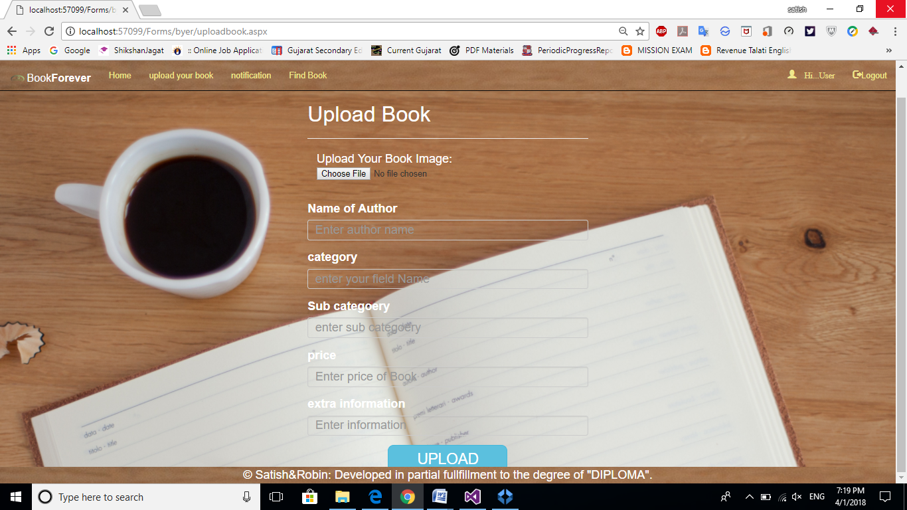

* This Page is for Seller to upload book information.
* This Page Contain Seller Details and Book Details.



**5.4 Admin add book:**

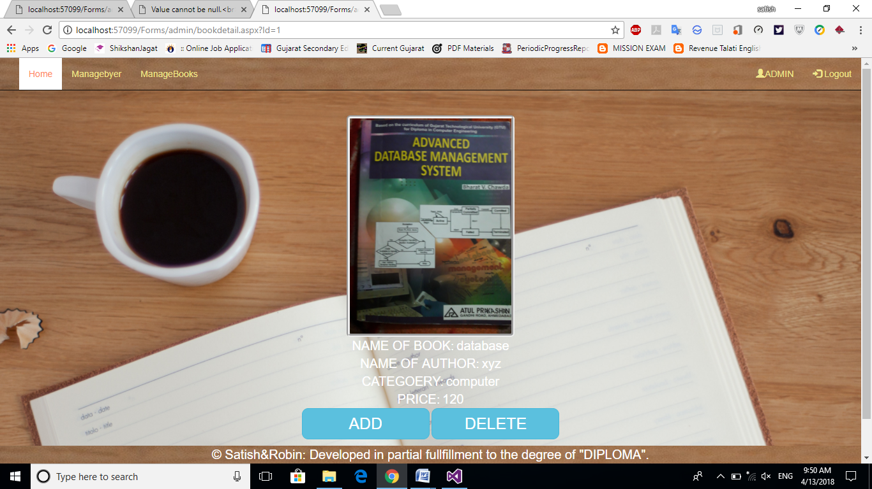

* This Page for Admin confirmation of book.
* This Page Contain list of information upload by seller admin give approval in

this page.

**5.5 View book :**

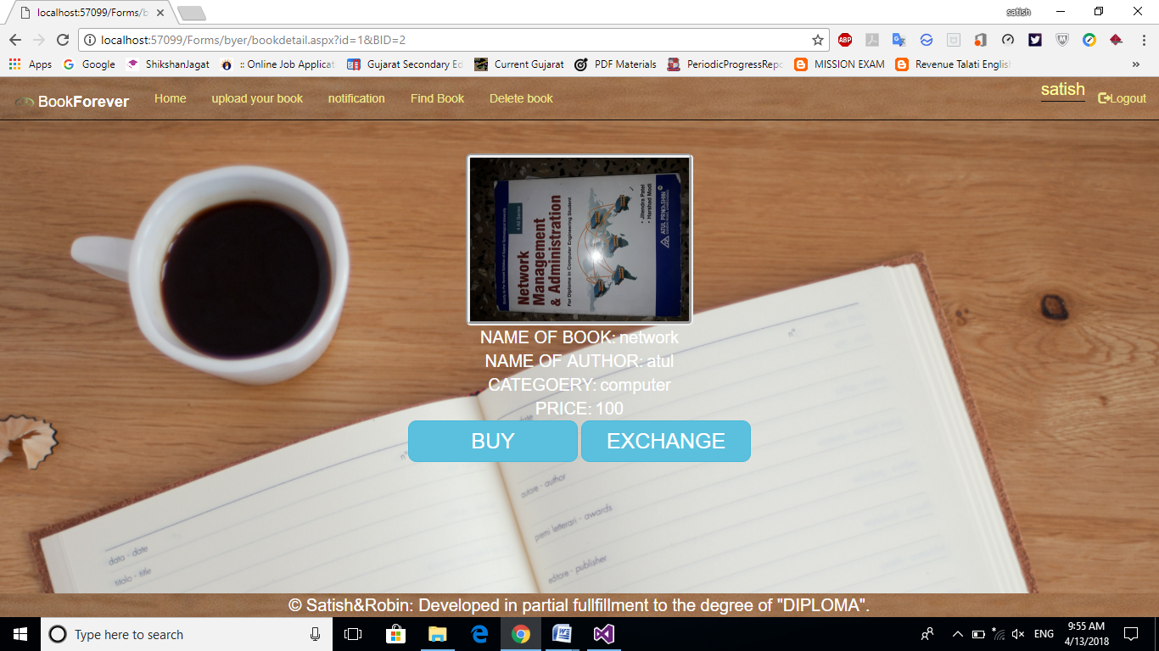

* This Page Contain list of information upload by seller so user can view.
* It provides detail description of the book.

**5.6 View Message :**

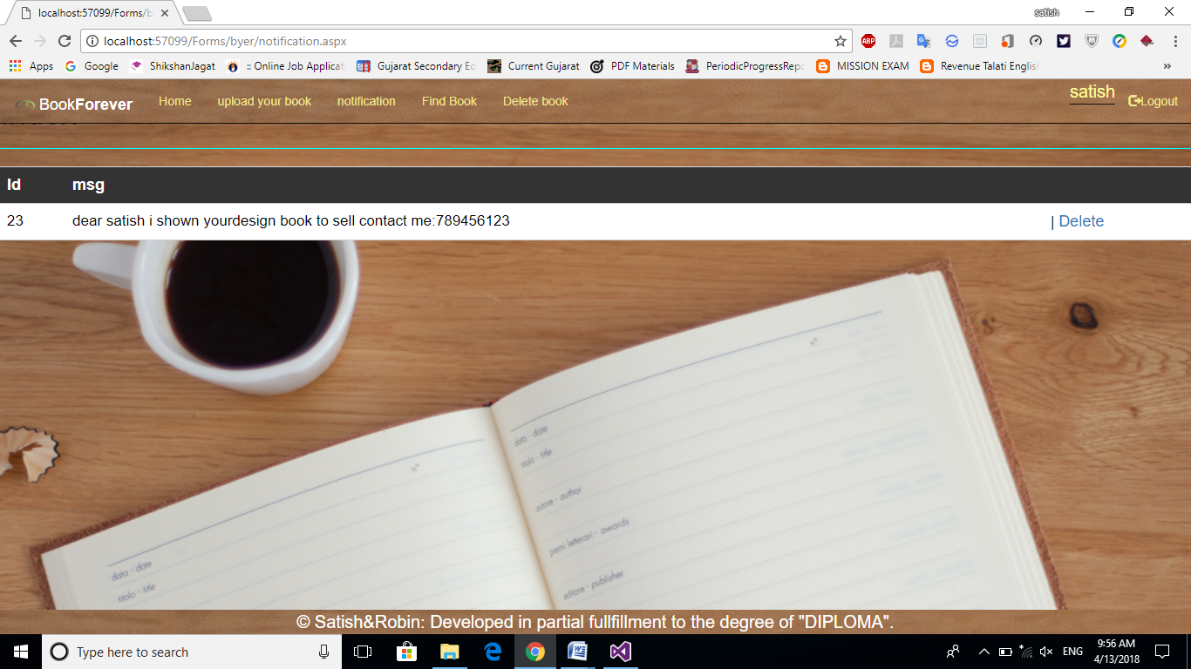

* This Page Contain list of Messages which is send by Buyer so Seller can view here.

**Chapter-6**

**TESTING**

**6.1TESTING PLAN**

**TESTING**

“Software testing is the process of analyzing a software item to detect the differences between existing and required conditions (that is, bugs) and to evaluate the features of the software item.”

The aim of testing is to identify all defects existing in a software product though not all. Software testing is an activity that should be done throughout the whole development process.

Therefore, we can safely conclude that testing provides a particular way of reducing defects in a system and increasing the user’s confidence in a development system.

**Black Box Testing:**

“Black box testing is testing that ignores the internal mechanism of a system or component and focuses solely on the outputs generated in response to selected inputs and execution conditions.”

It is also called functional testing. Therefore no reference to source code is required, and so even purchased modules can be tested. The program just gets an input and its functionality is examined by observing the output.

**White Box Testing:**

“White-box testing is testing that takes into account the internal mechanism of a system or component.”

White-box testing is also known as structural testing, clear box testing, and glass box testing. The connotations of “clear box” and “glass box” appropriately indicate that you have full visibility of the internal workings of the software product, specifically, the logic and the structure of the code.

Using the white-box testing techniques outlined in this chapter, a software engineer can design test cases that :

1. Exercise independent paths within a module or unit;
2. Exercise logical decisions on both their true and false side;
3. Execute loops at their boundaries and within their operational bounds; and
4. Exercise internal data structures to ensure their validity.

**6.2 Test case,Test data and Expected Result**

**Test Case 1: For Login**

|  |  |  |  |
| --- | --- | --- | --- |
| **Test case** | **Test data** | **Expected Result** | **Actual** |
|  |  |  | **Result** |
|  |  |  |  |
|  | Username=admin | Admin will be redirected to |  |
|  |  | homepage with name | Pass |
|  | Password=admin | displayed. |  |
|  |  |  |  |
|  | Username=Satish | User will be redirected to |  |
|  | Password=778899 | homepage with name | Pass |
|  | displayed. |  |
|  |  |  |  |
|  | Username=(blank) | System should not accept |  |
| Login |  | form to submit due to |  |
| Process | Password=admin | javascript validation. | Pass |
|  |  |  |  |
|  | Username=admin | System should not accept |  |
|  |  | form to submit due to |  |
|  | Password=(blank) | javascript validation. | Pass |
|  |  |  |  |
|  | Username=(blank) | System should not accept |  |
|  |  | form to submit due to |  |
|  | Password=(blank) | javascript validation. | Pass |
|  |  |  |  |

**Test Case 2: For Registration**

|  |  |  |  |
| --- | --- | --- | --- |
| **Test case** | **Test data** | **Expected Result** | **Actual** |
|  |  |  | **Result** |
|  |  |  |  |
|  | Name,Password, | If all specified data are |  |
|  | Address,Contact | given user will be |  |
|  | no etc | redirected to homepage | Pass |
|  |  | after success in |  |
|  |  | registration. |  |
|  |  |  |  |
|  | Password and | If Password and Confirm |  |
| Sign-Up Form | Confirm | Password then only user |  |
| Password if same. | can proceed. | Pass |
|  |
|  |  |  |  |
|  | Password and | Password mismatch error |  |
|  | Confirm | message will be shown. |  |
|  | Password are |  | Pass |
|  | different. |  |  |
|  |  |  |  |

**Test Case 3: Add Book**

|  |  |  |  |
| --- | --- | --- | --- |
| **Test case** | **Test data** | **Expected Result** | **Actual Result** |
| Add  Book | User provides Book Name, Author Name, price, image, description. | If data of any field is not blank data will be inserted into database. | Pass |
| Here all field are related to Book info if its not fill up | Error message will be displayed to user | Pass |
| If any of the required field is blank. | Error message will be displayed to user. | Pass |

**6.3 Coding**

<%@ Page Title="" Theme="Theme" Language="C#" MasterPageFile="~/Forms/Masters/byerhome.master" AutoEventWireup="true" CodeFile="byerhome.aspx.cs" Inherits="Forms_Visitor_Default" %>

<asp:Content ID="Content1" ContentPlaceHolderID="byerhomeHead" runat="Server">

<style type="text/css">

.auto-style2 {

width: 301px;

}

.auto-style3 {

width: 261px;

}

.auto-style4 {

margin-left: 76px;

}

</style>

</asp:Content>

<asp:Content ID="Content2" ContentPlaceHolderID="byerhomeBody" runat="Server">

<div class="container">

<div class="auto-style6 col-md-4 " style="text-align:center; height: 634px; margin-top: 20px; ">

&nbsp&nbsp&nbsp&nbsp&nbsp&nbsp&nbsp&nbsp&nbsp&nbsp

<asp:DataList ID="DataList1" runat="server" CellPadding="0" CellSpacing="50" DataKeyField="Id" DataSourceID="SqlDataSource1" RepeatColumns="4" RepeatDirection="Horizontal" Width="910px" Height="500px" >

<ItemTemplate>

<table class="auto-style2">

<tr>

<td class="auto-style7">

&nbsp;</td>

<td class="auto-style4">

&nbsp;</td>

<td rowspan="3" class="auto-style3">&nbsp;</td>

</tr>

<tr>

<td class="auto-style7">&nbsp;</td>

<td class="auto-style4">

<asp:Image ID="Image1" runat="server" class="img-rounded" Height="300px" ImageUrl='<%# Eval("img") %>' style="border-style: groove; border-width: 5px;" Width="318px" CssClass="auto-style4" />

</td>

</tr>

<tr>

<td class="auto-style8">

&nbsp;</td>

<td class="auto-style4">

<asp:HyperLink ID="HyperLink1" runat="server" Font-Bold="True" Font-Size="X-Large" NavigateUrl='<%#"/Forms/byer/bookdetail.aspx?id="+Eval("id")+"&BID="+Request.QueryString["BId"]%>' Text='<%# Eval("sub_categoery") %>'></asp:HyperLink>

</td>

</tr>

</table>

</ItemTemplate>

</asp:DataList>

&nbsp;<br />

<asp:SqlDataSource ID="SqlDataSource1" runat="server" ConnectionString="<%$ ConnectionStrings:ConnectionString %>" SelectCommand="SELECT * FROM [Books]"></asp:SqlDataSource>

</div>

</div>

</asp:Content>

**Chapter-7**

**LIMITATION AND FUTURE ENHANCEMENT**

* 1. **Limitation**
* The project does not provide online transaction. So the buyers will not be able to make online payment.
* The project does not provide online transaction. So the seller will not be able to get online payment.
  1. **Future Enhancements**
* Online payment getway is there.
* User can chat to each other for Buying/Selling Books.
* In future we will provide an inquiry message facility
* User can add multiple images of properties

**CONCLUSION**

* The Website can Buying, selling and Exchanging old book at online. It’s advantage is save the time and it’s helpful for save environment of Book-reuse.

**Chapter-8**

**REFERENCES & BIBLIOGRAPHY**

**BIBLOGRAPHY**

* During the development of my project, I have taken help of many books, and websites for reference, which I would like to humbly mention in this section. I hereby sincerely express my gratitude to all authors, publishers, web designers, software developers of these books and websites which we used as materials.
* These books, web sites acted as our tutor cum guide during the project Development.

**Reference**

* **Reference Book:**
* SAMS ASP .NET. 4.0 Unleashed
* Stephen walther.
* **Reference Sites:**
  + - * **www.tutorialpoints.com**
      * **www.w3schools.com**
      * [**www.bookwalaonline.com**](http://www.bookwalaonline.com)
      * [**www.stackoverflow.com**](http://www.stackoverflow.com)